

### College of Engineering

Department of Mechanical Engineering

Project Description Document (PDD)

Engineering Design-Senior Design, ME-490A

Project 18, Team M9, Automated Microgreen Growing Machine

Mean Green Growing Machine

John Berger, Max Merritt, Thuyavan Sathiamurthi, Conor Vasiliadis

11 September 2020

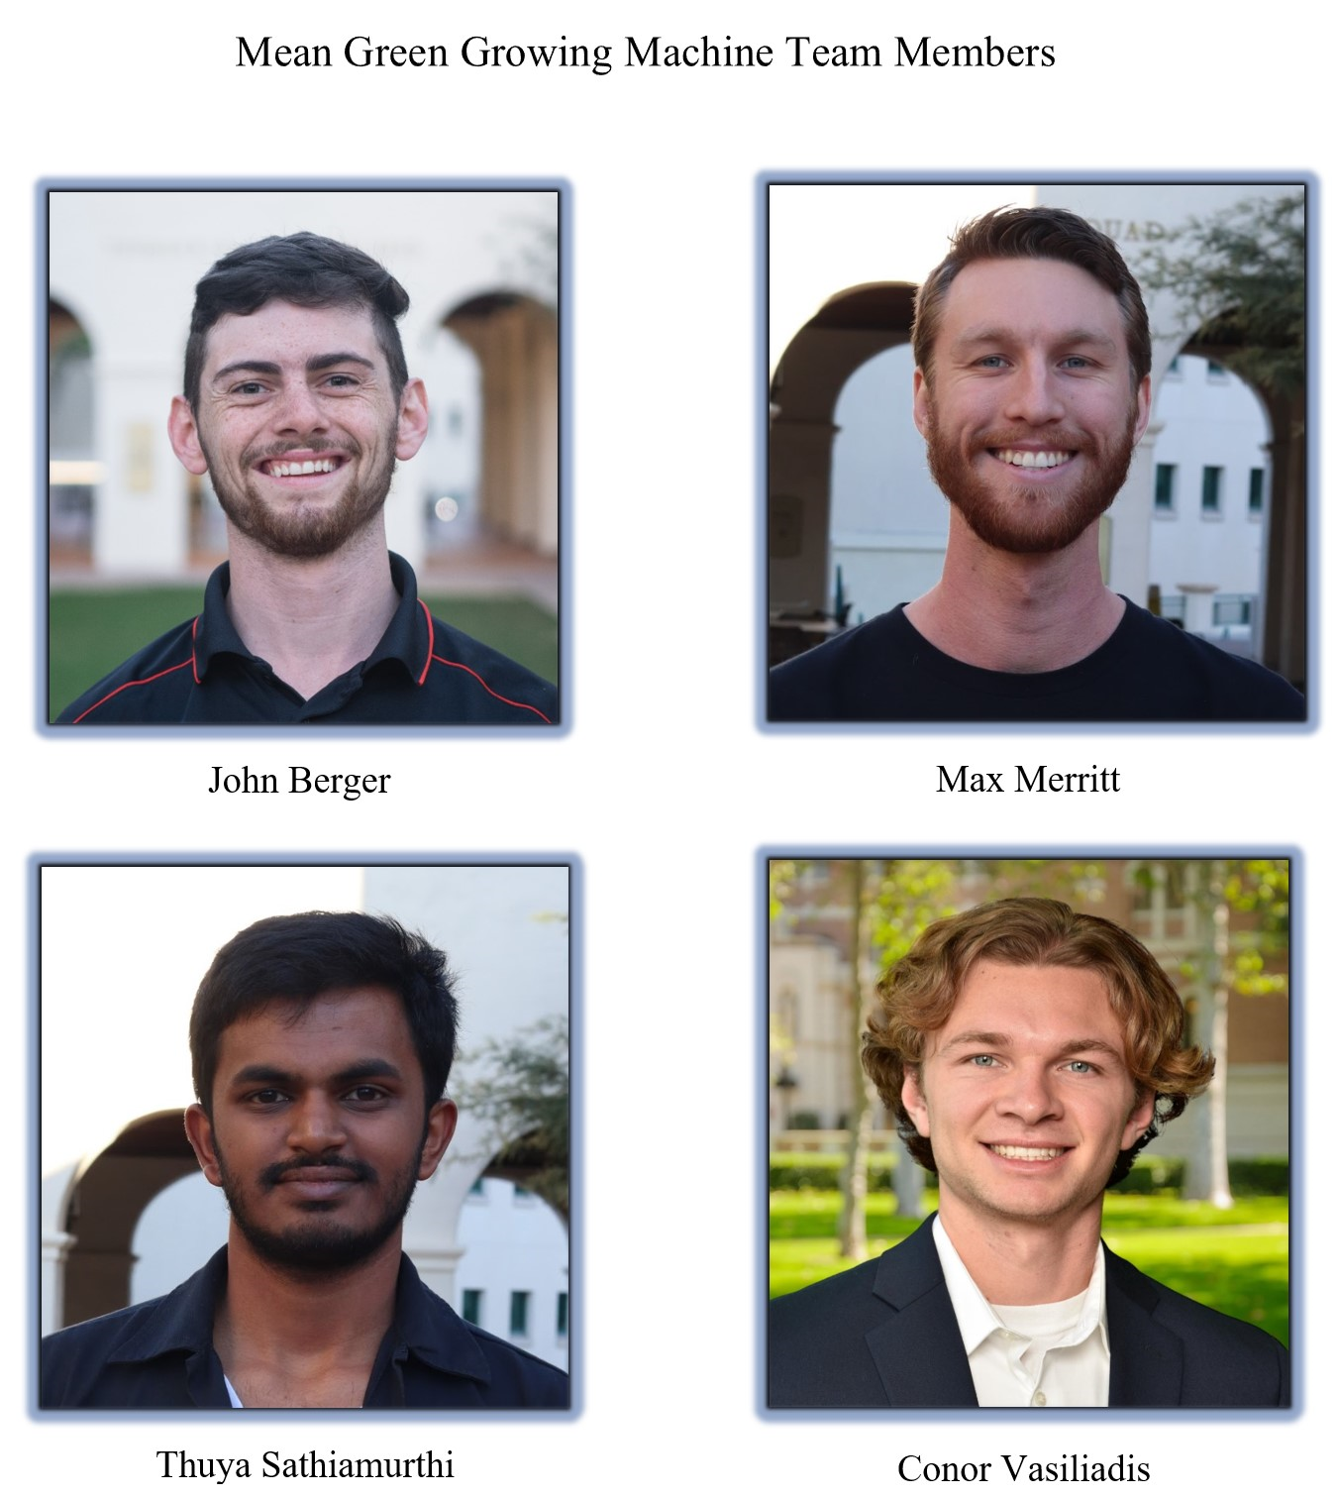

**Project Title:** Automated Microgreens Growing Environment

**Members:** John Berger, Max Merritt, Thuyavan Sathiamurthi, Conor Vasiliadis

**Sponsor(s):** Zip Launchpad/John Berger

**Problem Statement:**

There is an increasing demand for microgreens due to the higher concentration of nutrient contents compared to fully grown plants. However, with microgreens being a relatively new industry with few suppliers, consumers can find it difficult to find markets that sell the product. Where microgreens are found, they are usually priced at a premium due to the nutritional content and niche appeal of the product.

**Need:**

Our team seeks to design and analyze an automated growing environment, which will allow consumers to produce their own microgreens at home. To accomplish this, we will need to research the microgreen growing process. System functionality will need to be tested and tuned for optimal plant mass output and growth period. The overall design will also have to be optimized to be economically viable as a consumer product.

**User Requirements:**

The device should be treated as a household appliance and needs to be sturdy and portable. Users will need to supply the device with power (from a wall outlet) and water which may be a hard line from the household or by means of a water tank. Growing the microgreens will require the user to input the seeds and nutrients for every new cycle of the greens grown. The machine will automatically grow the greens by varying temperature, light, water level and nutrient dosage. The greens will be harvested by the user once they are mature and should provide enough greens for at least one serving a day.

**Engineering Specifications:**

|  |  |
| --- | --- |
| **Engineering Specification** | **Justification** |
| Device will produce 2 cups of microgreens per day, with a 3 day harvest window. | 6-7 cups per week will make the device economically viable to the consumer |
| Five year product lifecycle | 5 years minimum product life before service of parts or replacement is needed. Similar to many consumer products |
| Device will be load bearing (Can be sat on by the 95th percentile male, used as a shelf) | Device needs to be able to stack on a counter or be stacked on for space conservation |
| Device mass not to exceed 40kg | Over 40kg would make the device too cumbersome for the average consumer |
| Device volume not to exceed .5 m^3 | The device should be portable/can be installed in any standard home. |
| Device will be rated for indoor use only | Creating a device that will be able to function outdoors is much more expensive due to factoring in weather conditions |
| Climate control: maintain growing temperature between 18°C-24°C with ambient temperature up to 30°C | Greens generally need to be kept at an optimal temperature otherwise they will grow more slowly/perish |
| Watering: Scheduled watering frequency and duration to maximize plant growth. | Automatic watering will reduce the amount of work from the user |
| Lighting: Controlled light duration and intensity to maximize plant growth. | Automatic lighting will reduce the amount of work from the user |
| Nutrient/PH: Nutrient and PH balancing to maximize plant growth | Automatic Nutrient/PH control will reduce the amount of work from the user |

**Project Schedule (IMP):**

* Project Kickoff: 9/5/2020
* ME-490A Project Management Plan (PMP): September 20, 2020
* ME-490A System Requirements Document (SRD): October 2, 2020
* ME-490A Preliminary Design Review (PDR): October 24, 2020
* ME-490A Critical Design Review (CDR): November 28, 2020
* ME-490A Final Report: December 11, 2020
* Start component purchasing: January 1, 2021
* ME-490B Manufacturing Design Review (MDR): February 15,2021
* ME-490B Testing Review: March 15, 2021
* Start plant growth optimization/data collection: March 8, 2021
* Manufacturing Complete: April 1, 2021
* Final product testing & Final ECE integration: April 8, 2021
* ME-490B Final Presentation and Product Demo: April 26, 2021
* ME-490B Design Day: May 2021
* Project Conclusion: May 15, 2021

**Project Budget:**

|  |  |
| --- | --- |
|  | **Original Supplied:** |
| **Sponsor Donations:** | **$1500** |
| **Team Contributions:** | **$800** |
| **Total Budget:** | **$2300** |

Basis of estimate: This initial budget estimate is based on the following breakdown of predicted costs per system, as well as a 15% management reserve. A higher than average management reserve was selected due to the uncharted nature of the project.

|  |  |
| --- | --- |
| **System:** | **Budget:** |
| Enclosure/Structural | $250.00 |
| Watering | $150.00 |
| Lighting | $275.00 |
| Climate Control | $50.00 |
| Plant Supplies | $150.00 |
| Nutrient/PH Control | $425.00 |
| Management Reserve | $195.00 |
| **Total:** | **$1,495.00** |

Funding Sources: Sponsor donation is funding supplied by John Berger. Team Contributions include any personal contributions from teammates, and any team-acquired industry sponsorships or donations.